Supplementary Materials for

Sequential integration of multimodal data from serum improves the predictive performance of hepatic lipid accumulation in mice.

Martin David, Monbet Valérie, Leroyer Patricia, Oliviero Nolwenn, Turlin Bruno, Salim Zerrouki, Fautrel Alain, Ropert Martine, Sire Olivier, Loréal Olivier.

Corresponding author: David.martin.2@univ-rennes.fr

This PDF file includes:
Figures S1 to S4.
Table S1.

Figure S1: Experimental design. Mice were subjected either to a control diet or to a high-fat, high-carbohydrate (HFHC) diet, and, independently, received injections of either dextran or iron-dextran. The steatosis (i.e., hepatic lipid accumulation) has been evaluated through 3 biological scales. We constructed several datasets. The first dataset consists of biochemical measurements from serum. The second dataset is derived from mid-infrared (MIR) spectroscopy performed on serum, providing molecular fingerprints specific to each mouse. The third dataset comprises quantitative measurements of metals and trace elements in the serum.

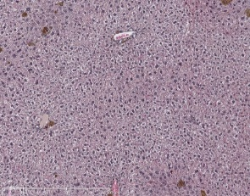
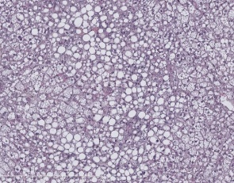
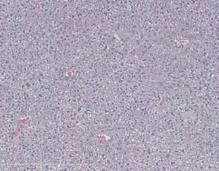
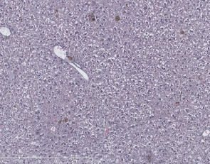
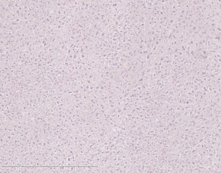
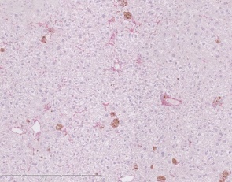
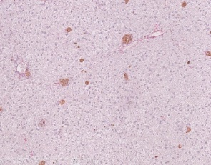
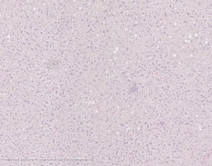
CTL
HFHC
IRON
IRON + HFHC
Sirius Red
HES

Figure S2. Liver staining. HES and Sirius Red staining of the liver of CTL, HFHC, IRON, and IRON/HFHC mice at 22 weeks. The scale bar corresponds to 500µm. Black arrows are related to the extracellular matrix.

Figure S3. Representative spectra, with the important wavenumbers defining the lipid accumulation in the liver of mice. (A) Representative absorbance spectrum of the mid-infrared spectroscopy. The arrows correspond to the wavenumbers 1230, 1180, 950, 850 cm⁻¹. (B) The heatmap corresponds to the importance of the wavenumbers in the random forest of the sequential approach. The more the wavenumbers are colored (differ from the blue), the more the wavenumbers are important to predict the lipid accumulation in the liver. The y-axis of the plot corresponds to the B-spline width used in the normalisation process.

a
b
a,b
a,b
a,b,c
a
a,b,c
b
a,c
a,c
b
b
a,b
a
a
a
a
a
a
a
a
a,b,c
a
a,b

Figure S4. Heatmap of trace element levels across experimental groups. Increasing intensity of blue indicates higher values. Abbreviations: manganese (Mn), iron (Fe), copper (Cu), cobalt (Co), zinc (Zn), selenium (Se), rubidium (⁸⁵Rb), molybdenum (Mo), arsenic (As). Statistically significant differences are annotated as follows: a denotes a significant difference versus CTL, b versus HFHC, and c versus IRON. Statistical analysis was performed using multiple pairwise Wilcoxon tests with Bonferroni correction.

5’ - 3’ | Fwd | Re
A2m | GAAACAGAGATCAGCATGACCAGTA | CATTTGGATTTGTGGTAGAGGAACT
Crp | TGGTGGGAGACATCGGAGAT | GCCCGCCAGTTCAAAACAT
Hprt1 | CCGGAATCCCTATCTTTAGTCC | GGGTCAGTCCAGTGCCATAAG
Nrf2 | CGAGATATACGCAGGAGAGGTAAGA | GCTCGACAATGTTCTCCAGCTT
Fsp27 | ATGGACTACGCCATGAAGTCT | CGGTGCTAACACGACAGGG

Table S1. Primers used for liver tissue. Crp, C - reactive protein; Hprt1, hypoxanthine phosphoribosyltransferase 1; Nrf2, Nuclear factor (erythroid-derived 2)-like 2; A2m, α2-macroglobuline; Fsp27 Fat-specific protein 27.

